**Excel Assignment – 7**

1. **Using Insert Function, give examples of any function available in the different dropdowns present in the function library.**

Ans: A **function** is a **predefined formula** that performs calculations using specific values in a particular order. Excel includes many common functions that can be used to quickly find the **sum**, **average**, **count**, **maximum value**, and **minimum value** for a range of cells.  
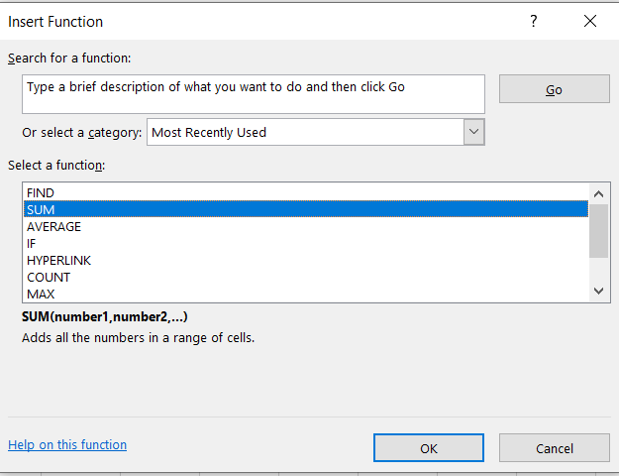

**Creating a function**

There are a variety of functions available in Excel. Here are some of the most common functions you'll use:

* **SUM**: This function **adds** all of the values of the cells in the argument.
* **AVERAGE**: This function determines the **average** of the values included in the argument. It calculates the sum of the cells and then divides that value by the number of cells in the argument.
* **COUNT**: This function **counts** the number of cells with numerical data in the argument. This function is useful for quickly counting items in a cell range.
* **MAX**: This function determines the **highest** **cell value** included in the argument.
* **MIN**: This function determines the **lowest cell value** included in the argument.

In the example mentioned, we'll use the **COUNTA** function to count the total number of items in the **Items** column. Unlike COUNT, **COUNTA** can be used to tally cells that contain data of any kind, not just numerical data.

1. Select the **cell** that will contain the function. In our example, we'll select cell **B17**.
2. Click the **Formulas** tab on the **Ribbon** to access the **Function Library**.
3. From the **Function Library** group, select the desired **function category**. In our example, we'll choose **More Functions**, then hover the mouse over **Statistical**.
4. Select the **desired function** from the drop-down menu. In our example, we'll select the **COUNTA** function, which will count the number of cells in the **Items** column that are not empty.
5. The **Function Arguments** dialog box will appear. Select the **Value1** field, then enter or select the desired cells. In our example, we'll enter the cell range **A3:A12**. You may continue to add arguments in the **Value2** field, but in this case we only want to count the number of cells in the cell range **A3:A12**.
6. When you're satisfied, click **OK**.
7. The function will be calculated and the result will appear.

**2. What are the different ways you can select columns and rows?**

There are several ways to select columns and rows in Microsoft Excel:

1. **Single column or row:** To select a single column or row, click on the column letter or row number.
2. **Multiple columns or rows:** To select multiple columns or rows, hold down the "Ctrl" key while clicking on the column letters or row numbers.
3. **Contiguous columns or rows:** To select contiguous (adjacent) columns or rows, hold down the "Shift" key while clicking on the first and last column letters or row numbers.
4. **Non-contiguous columns or rows:** To select non-contiguous (non-adjacent) columns or rows, hold down the "Ctrl" key while clicking on the column letters or row numbers.
5. **Entire sheet:** To select the entire sheet (all columns and rows), click the "Select All" button in the topleft corner of the sheet, or use the keyboard shortcut "Ctrl + A".
6. **Named ranges:** To select a range of cells that has been given a name, click the "Name Box" in the top-left corner of the sheet and type the name of the range.
7. **Using the mouse**: To select a range of cells using the mouse, click and hold the mouse button on the first cell, then drag the mouse to the last cell and release the button.
8. **Using the keyboard**: To select a range of cells using the keyboard, use the arrow keys to move to the first cell, hold down the "Shift" key, and then use the arrow keys to move to the last cell.

**3.** **What is AutoFit and why do we use it?**

AutoFit is a feature in Microsoft Excel that allows you to automatically adjust the width or height of a cell or a range of cells to fit the contents of the cell or range. The feature is useful when you have data in a cell or range of cells that is too large to be displayed in the current width or height of the cells, or when you want to adjust the size of the cells to better fit the data they contain.

There are several ways to use AutoFit in Excel:

To adjust the width of a cell or range of cells to fit the contents, select the cell or range, and then click the "Format" tab in the ribbon. In the "Format" tab, click the "AutoFit Column Width" button. This will adjust the width of the cells to fit the contents of the cells.

To adjust the height of a cell or range of cells to fit the contents, select the cell or range, and then click the "Format" tab in the ribbon. In the "Format" tab, click the "AutoFit Row Height" button. This will adjust the height of the cells to fit the contents of the cells.

To adjust the width and height of a cell or range of cells to fit the contents, select the cell or range, and then right-click on the selection and choose "Format Cells" from the context menu. In the "Format Cells" dialog box, click the "Alignment" tab, and then check the "Wrap text" checkbox. This will wrap the text in the cells and adjust the width and height of the cells to fit the contents.

**4. How can you insert new rows and columns into the existing table?**

**Ans:** Here are few ways mentioned:

* To insert new rows or columns into an existing table in Excel, you can follow these steps:
* Select the cell where you want to insert the new row or column.
* Right-click on the selected cell and choose "Insert" from the context menu.
* In the Insert dialog box, choose either "Entire row" or "Entire column" to specify whether you want to insert a new row or column.
* Click "OK" to insert the new row or column.

**5.How do you hide and unhide columns in excel?**

**Ans:** To hide a column in Excel, right-click on the column letter at the top of the worksheet and select

"Hide" from the context menu. To unhide a column, right-click on any column letter and select "Unhide" from the context menu. This will open the "Unhide Columns" dialog box, where you can select the column or columns that you want to unhide. You can also use the "Format" dropdown in the "Cells" group on the "Home" tab of the ribbon to hide and unhide columns. Simply select the column or columns that you want to hide or unhide, and then click the "Hide & Unhide" button in the "Format" dropdown.

On the Home tab, in the Cells group, click Format. Do one of the following: Under Visibility, click Hide & Unhide, and then click Unhide Rows or Unhide Columns.

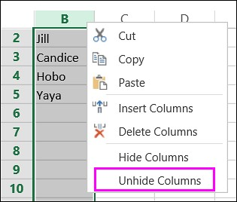

**6. Create an appropriate table within the worksheet and use different functions available in the AutoSum command.**

Ans: 